Design approach and verification for UC3M’s ST3LLARsat1 Boira CubeSat’s Thermal Control Subsystem
Carlos García Gómez, Miguel Cruzat Hurtado, Alison Ponche, Antonio Acosta Iborra, and Andrés Marcos
ST3LLARsat1 Boira is the 1st student CubeSat being developed at UC3M, and in this article the current status on the design of its thermal control system is presented. This design poses numerous challenges due to the limited mass and low thermal capacitance available in CubeSats, making them vulnerable to temperature fluctuations. Therefore, it is of utmost importance to address in the design of the thermal control system the high heat flux densities experienced by internal electronic components and the rapid changes in the external orbital environment. In addition, Boira’s thermal-related requirements include the ability to withstand a non-operational temperature range for the spacecraft of [-20,+60] Cº. Additionally, all units and parts must also be kept within their own temperature ranges.
Boira’s temperature control system component is based on an integrated EPS module, which includes the heater and battery sensors, along with appropriately selected painting and coatings. Initially, an analysis of available design procedures was conducted. The mission requirements led to the definition of four modes: LEOP, nominal, science and safe, each requiring different thermal settings.
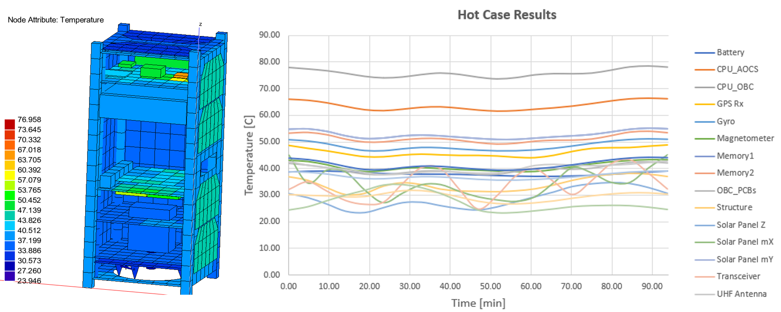
Figure 1: Temperature profile evolution for Boira CubeSat.

To regulate the heat and analyze the system's response to the environment and activation of the heater under nominal orbital conditions, a spacecraft thermal simulator has been developed using ESATAN - TMS. The simulator allows to verify the thermal system and to test various parameters, supporting the evolution of its design.

The techniques employed highlight the importance of established thermal control approaches for CubeSats, which are taking on expanding roles and facing more demanding requirements.
This work provides an overview of the key thermal aspects for the status of the thermal control system of UC3M’s ST3LLARsat1 Boira. This includes the usual methodology for designing a thermal control subsystem for CubeSats and the initial thermal design used for the Baseline Design Review for ESA’s Fly Your Satellite! Program. This analysis show that two of the components are not inside their respective temperature ranges. In this way design solutions are given to correct those issues.

* Miguel Cruzat is currently a Thermal Engineer at Madrid Space. He was a Master of Space Engineering (MISE) student at UC3M when this work was performed.

