Synchronized CubeSats for GNSS-R
Eliott Hubin¹, Laurent Paucot¹, Jan Thoemel², Christophe Craeye¹
¹ Université catholique de Louvain, Belgium
²Interdisciplinary Centre for Reliability, Security and Trust (SnT), University of Luxembourg, Luxembourg

Satellite Earth observation refers to the collection and processing of data imaging the Earth's features using payloads mounted on satellites. Over the last several years, the number of companies involved in this field has significantly increased. A diverse range of sectors depend on Earth observation to adopt more sustainable practices. Earth observation using reflected GNSS signals has been developing since the 1990s. The main advantage of GNSS reflectometry is that it does not require RF signal transmission from the same satellite, known as the opportunity concept.
In the context of GNSS-R, the ability to focus on narrow regions of the Earth's surface is of interest, necessitating the use of highly directive antennas. However, a challenge arises as the antenna's directivity is proportional to its characteristic length for a given wavelength. Antennas with an extensive aperture have been used until now, resulting in significant implementation costs and mechanical difficulties. Consequently, alternative solutions are required. A potential solution proposed is to replace large aperture antennas with an antenna array that utilizes a swarm of CubeSats.
The study identifies suitable CubeSat configurations for antenna array synthesis and defines quantitative targets for resolution and side lobe levels near the specular point. The proposed system operates at an orbital distance of 400 km above the Earth's surface and aims to achieve a remarkable 1-kilometer resolution in Earth observation. This ambitious goal will be accomplished through the deployment of a swarm consisting of 30 satellites that operate in a relative orbit around a chief satellite, grounded in the principles of the Clohessy-Wiltshire equations. These equations govern the dynamics and relative motion of the satellites, enabling precise control and coordination within the swarm.
A novel methodology is proposed to determine the most optimal CubeSat configurations. This innovative approach leverages the computation of the ground spot, shedding light on the direct illumination of the RF signal on the Earth's surface. By analyzing the ground spot, valuable insights are gained into the physics of the system, enabling the identification of the most suitable satellite configurations. This methodology offers a comprehensive understanding of the direct RF signal interaction with the Earth's surface, contributing to the selection of configurations that maximize the performance. The findings reveal, among other things, that such configurations have continuous aperture-like behavior near the main beam and that the size of this zone is predictable. It has also been demonstrated the feasibility of generating configurations with 1-kilometer resolution while simultaneously maintaining sufficiently low side lobes in the glistening zone, ensuring the ability to perform source localization and separation without encountering any ambiguity concerns.
In addition, this work addresses challenges related to digital beamforming and radar localization in a 10 km diameter disk glistening zone for Earth imagery production. It discusses synchronization challenges caused by the inability to transmit the local oscillator through transmission lines and proposes a solution using a chief CubeSat broadcasting its local oscillator to the rest of the swarm. The characterization of a first antenna array composed of two CubeSat prototypes is proposed. It demonstrates, as a first milestone, that the system is able to perform single source localization using digital beamforming.

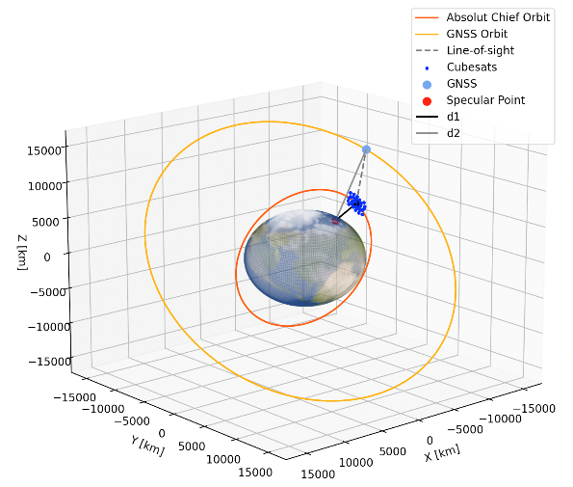 | 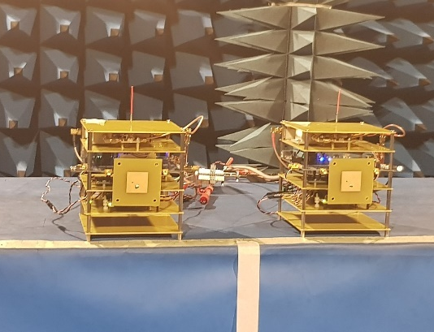
Figure 1: Absolute CubeSat Configuration | Figure 2: CubeSat prototypes

