AetherSat-1: Design exploration of a CubeSat re-entry mission with an inflatable Thermal Protection System
Roemer Spreij^{1,2}, Tom Van Steenbergen¹, Witse Janssens, Ariël Verschueren¹, Michiel Wauters, Brecht De Vuyst, Marijn Gielen, Mathieu Erbas, Valentijn De Smedt¹, Jurgen Vanhamel³
¹ KU Leuven
² von Karman Institute for Fluid Dynamics
³ TU Delft
AetherSat-1 is a 3U CubeSat under development by the Aether Student CubeSat team at KU Leuven. The team collaborates with the von Karman Institute for Fluid Dynamics (VKI), with the goal of performing research into atmospheric entry and demonstrating the use of an inflatable Thermal Protection System (TPS) for small satellites. AetherSat-1 is intended as a precursor to an affordable mission platform used for entry research and the targeted return of on-board experiments from LEO. This paper presents the current state of the mission’s design and motivates the choices made.
The mission profile is based upon a re-entry from LEO, comparable to the QARMAN mission of VKI [1]. After deployment, the satellite spends a period of time (dependent on launch/deployment opportunities) in a naturally decaying orbit. A proposed payload for this mission stage is a Sweeping Langmuir Probe (SLP) to study the ionosphere over a range of altitudes [2]. The TPS inflation occurs when a target altitude is reached shortly before entry. During entry, the aerothermal environment around the TPS is monitored by temperature and pressure measurements. Data is stored in an onboard ‘black box’ and broadcast via satellite network after the blackout phase and before reaching the surface. Another proposed payload for the TPS is a shape monitoring system using Fibre Bragg Gratings (FBGs) embedded in the flexible aeroshell membrane, that will measure the deflection of the TPS under aerodynamic and thermal loading. In later missions, real-time information of the aeroshell shape could be used together with mechanical or inflatable actuation of the aeroshell to influence the satellite’s trajectory [3].
VKI in-house tools are used to simulate the trajectory of the satellite, during the orbital decay phase and the re-entry proper. The aerodynamic estimation tools ‘SMARTA’ (valid in the rarefied regime) and ‘ANTARES’ [4] (valid in the hypersonic continuum regime) are used to form an aerodynamic database of the satellite, which is then used by the entry trajectory simulator ‘ROVT’. Rarefied simulations show that the orbit of AetherSat-1 will decay in 6-8 months from a 400 km deployment altitude.
The inflatable TPS is housed in the front unit of the CubeSat when stowed and forms a tension cone geometry when deployed (Figure 1). The aeroshell membrane is supported by an inflatable torus loaded under compression, which is inflated by means of a Cold Gas Generator (CGG). It has a rigid spherical nosecone. In the initial analysis, this geometry is approximated as a sphere-cone. The relevant geometric parameters (Cone angle and diameter) are optimized with respect to mass, static stability and peak heat flux, leading to an optimal set of heatshield designs. This optimization makes use of a surrogate model of the ROVT-ANTARES simulation pipeline, based on low-rank matrix decomposition by means of the Adaptive Cross Approximation algorithm [5]. Temperature and heat flux distributions along the flexible TPS surface are obtained with engineering methods (Figure 2).
The Aether Student CubeSat team, which is designing and building this satellite, is a student-managed project started in 2020 that aims for a launch in 2028. Besides pursuing the above-mentioned scientific and engineering objectives, Aether is also an educational project meant to give students practical experience working on a space mission and to connect them with industry.
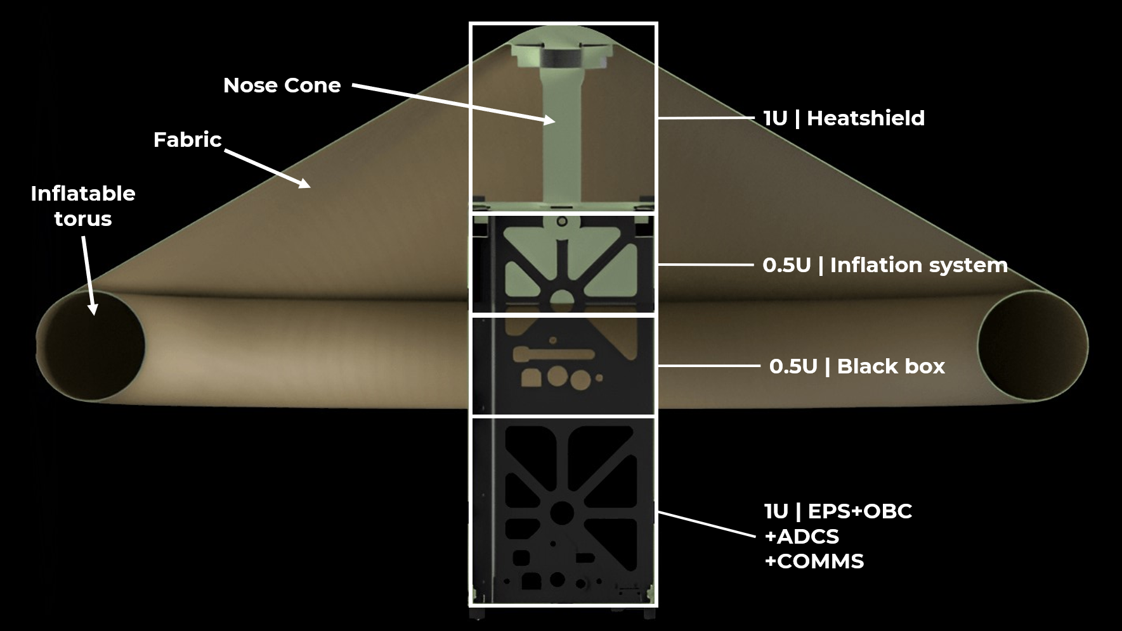
Figure 1: Schematic view of AetherSat-1 with its TPS deployed.
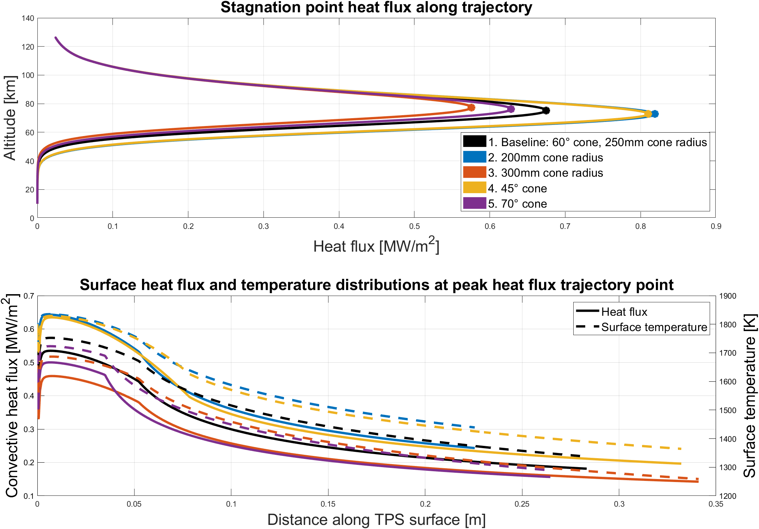
Figure 2: Heat flux estimations for various TPS configurations: stagnation point along trajectory (top); off-stagnation point at the peak heat flux trajectory point (bottom)

[1] P. Testani, E. Umit, T. Scholz, I. Sakraker, G. Baillet, and V. Van der Haegen, ‘QARMAN: An Atmospheric Entry Experiment on CubeSat Platform’, presented at the 8th European Symposium on Aerothermodynamics for space vehicles, Lisbon, Portugal, Mar. 2015.
[2] S. Ranvier, M. Anciaux, J. De Keyser, D. Pieroux, N. Baker, and J.-P. Lebreton, ‘SLP: The Sweeping Langmuir Probe Instrument to Monitor the Upper Ionosphere on Board the PICASSO Nano-Satellite’, presented at the 70th International Astronautical Congress (IAC), Washington D.C., United States, Oct. 2019
[3] J. Vanhamel, N. Eaton, and R. Spreij, ‘Using fiber bragg gratings for shape monitoring and adjustment of a thermal protection system aboard a targeted re-entry cubesat’, presented at the 2nd International Conference on Flight Vehicles, Aerothermodynamics and Re-entry Missions Engineering (FAR), Heilbronn, Germany, Jun. 2022.
[4] T. Durbin, G. Grossir, and O. Chazot, ‘Hypersonic aerodynamic predictions for arbitrary geometries using ANTARES’, presented at the HiSST: 2nd International Conference on High-Speed Vehicle Science & Technology, Bruges, Belgium, Sep. 2022.
[5] M. Bebendorf, “Adaptive cross approximation of multivariate functions,” Constructive Approximation - CONSTR APPROX, vol. 32, 10 2011.

To reach the authors of this paper please contact roemer.spreij@kuleuven.be

